DriverPass System Design Document
CS 255 Project Two
Chayce Jones
The DriverPass system would give customers and staff one website for managing driving lessons and training records. I used both process and object models to show the steps users follow and how the different records connect. The design is based on the DriverPass interview. The technical requirements also include recommendations that DriverPass would need to review before development.

UML Diagrams

UML Use Case Diagram
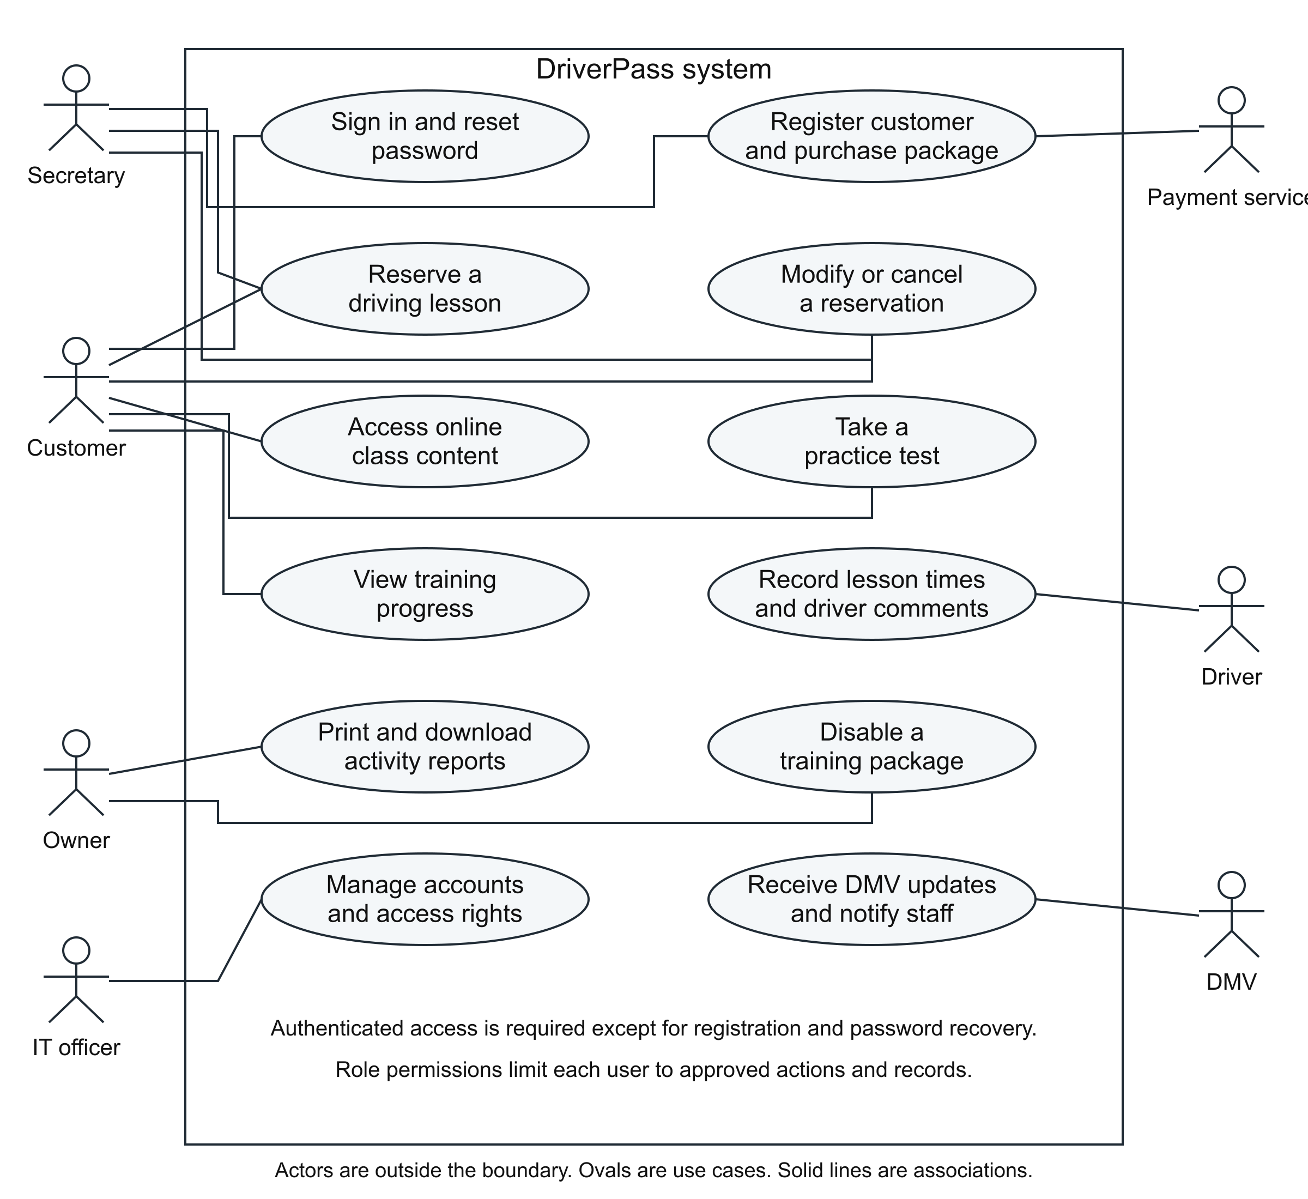
Figure 1 shows who would use the system and the tasks each person can complete. The people and outside services are outside the system boundary, while the DriverPass tasks are inside it. Users need to sign in before accessing protected information. In the first version, the secretary would register customers and record package purchases. I included a separate payment service as a design recommendation.

UML Activity Diagrams

Reserve a Driving Lesson
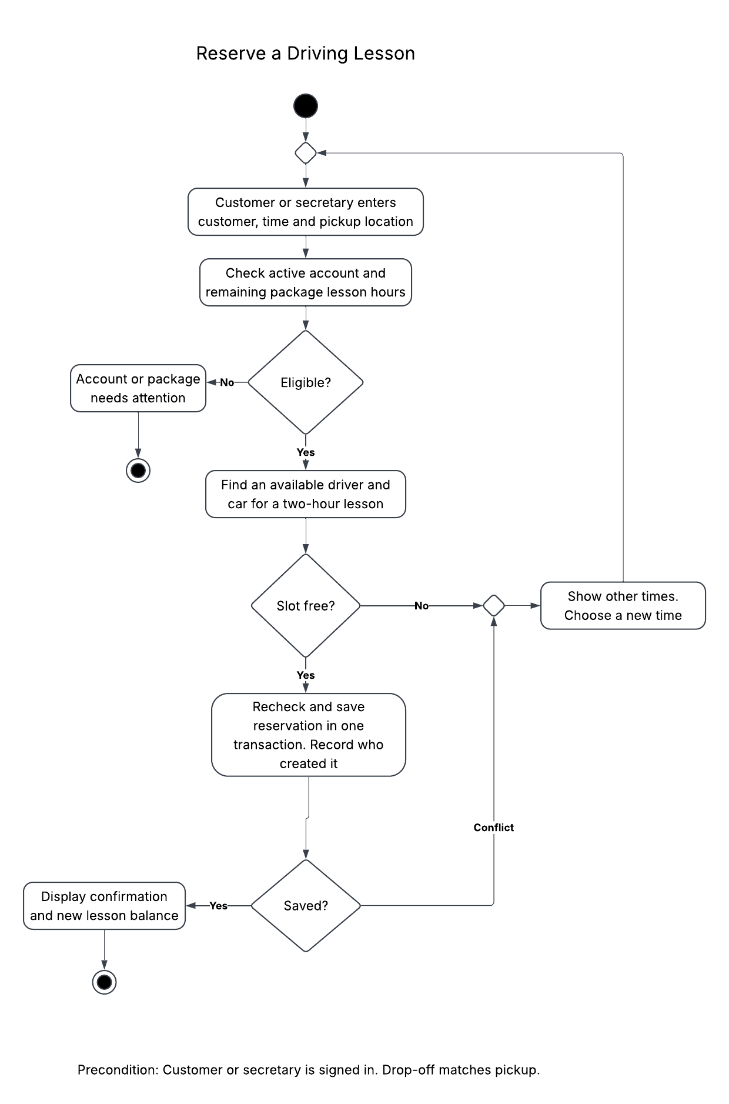
Figure 2 shows the steps for reserving a driving lesson. The decision points show what happens when the customer is eligible or a requested time is unavailable. If the user chooses another time, the flow returns to the availability check. Before saving, the system checks the customer, driver, car, and remaining lesson hours together. This helps prevent double bookings.

Take a Practice Test
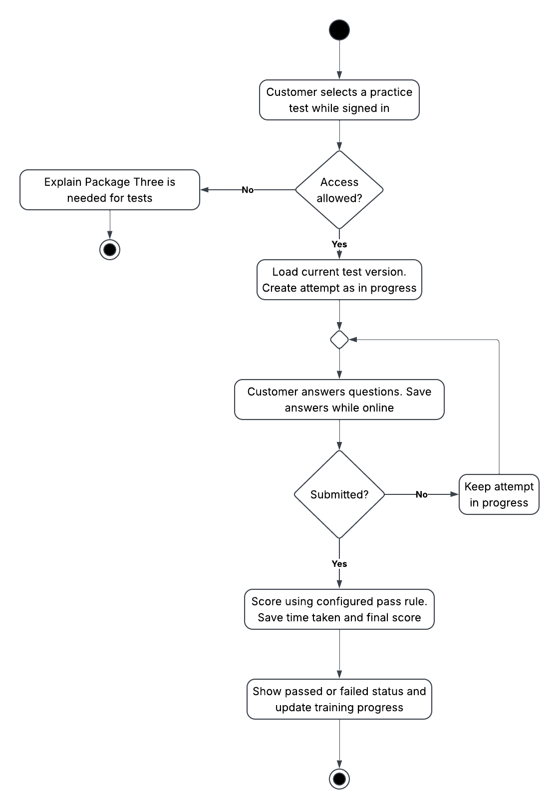
Figure 3 shows how a customer takes a practice test. The system checks that the customer has access through Package Three before starting the test. An unfinished test stays in progress. Once the customer submits it, the system saves the time taken, score, and passing or failing result. DriverPass would need to confirm the passing score because the interview does not provide one.

UML Sequence Diagram
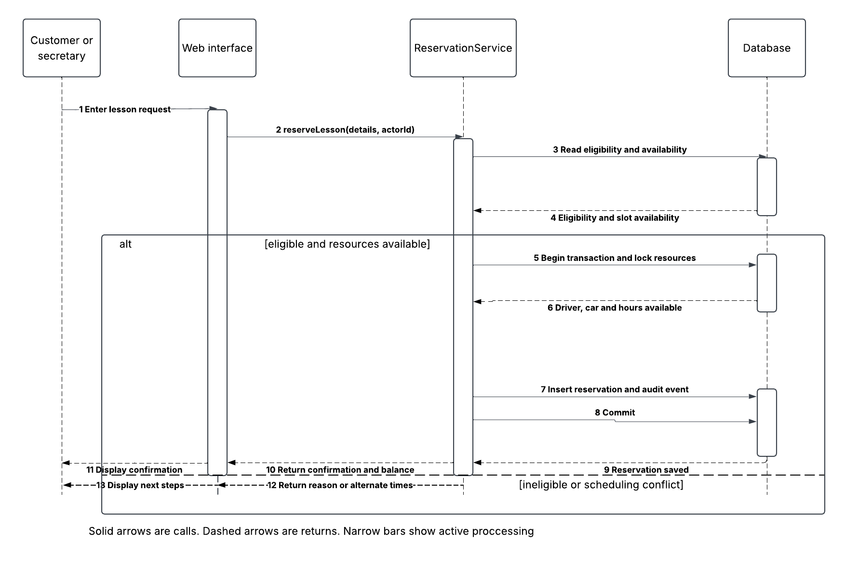
Figure 4 follows the same reservation process as Figure 2. The lifelines show the user, website, reservation service, and database. The activation bars show when each part is processing a request. Solid arrows show requests, and dashed arrows show the results coming back. The alternative paths show either a confirmed booking or a problem with eligibility or availability.
The database needs to save the reservation and its activity history together. If another booking takes the requested time before the save finishes, the system should cancel that save and explain the conflict. Each request should have a unique identifier so retrying it does not create a duplicate reservation. The website should only show a confirmation after the reservation has saved successfully.

UML Class Diagram
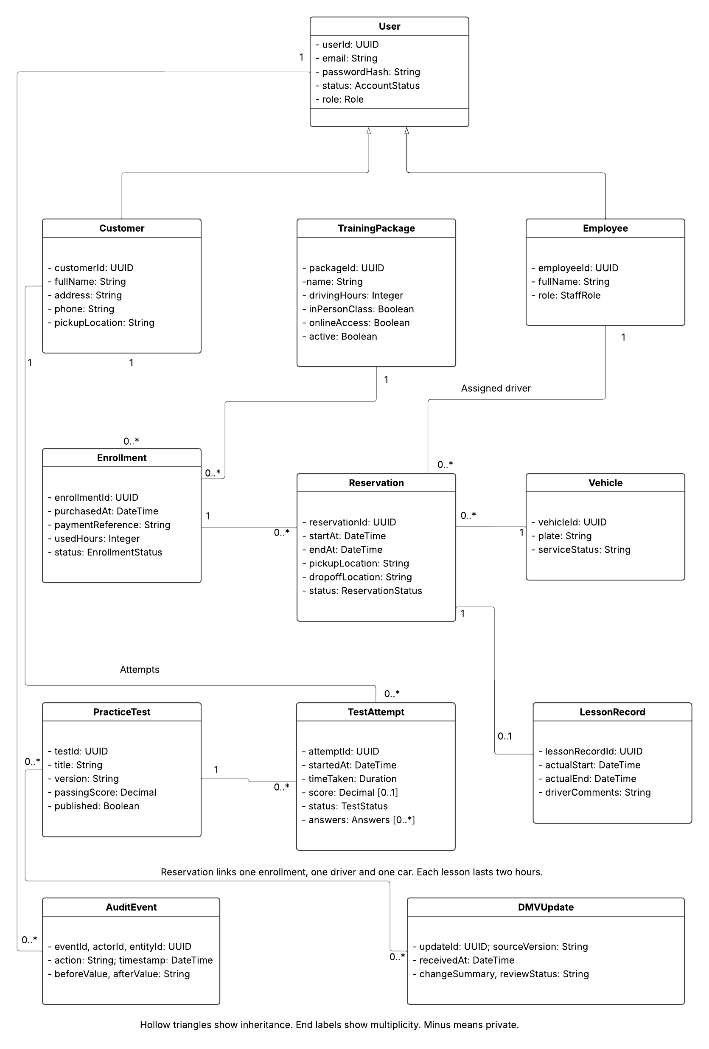
Figure 5 shows the main classes, their attributes, and how they relate to each other. Customer and Employee inherit the shared account fields from User. The diagram also includes AuditEvent for activity history and DMVUpdate for changes to training information. The role and status fields use defined sets of values. The technical requirements below explain the rules the system needs to check when it uses these records.

Technical Requirements

Hardware and Access
DriverPass would need office computers with current web browsers and reliable internet access. Customers could use a computer, tablet, or smartphone. Drivers would also need browser access to enter lesson times and comments. Staff would need a printer for paper reports. Since the system would run in the cloud, DriverPass would not need a local application server. The system would track the ten cars described in the interview without requiring new equipment in the cars.
As a starting recommendation, the application could use a cloud instance with 2 virtual CPUs and 4 GB of memory. The managed database could start with 2 virtual CPUs and 8 GB of memory. These are planning estimates. Load testing would help determine the actual capacity and storage needed before launch. The provider should also allow DriverPass to add capacity as more customers use the system.

Software and Infrastructure
I recommend a website built with HTML, CSS, and JavaScript that adjusts to different screen sizes. The server application would handle signed-in requests for accounts, scheduling, training, and reports through HTTPS. A managed relational database would store the connected records and enforce required fields and transactions. PostgreSQL is my proposed database. Cloud storage would hold training files and exported reports. A scheduled cloud service could check for DMV updates and send notifications through an approved email service.
The database should stay on a private network, with access limited to the application and approved administration tools. Developers should use separate development, testing, and production environments. Service credentials should stay in a managed secret store. Monitoring should track application errors, failed background tasks, storage use, and backup failures. The cloud provider would manage the underlying infrastructure, while DriverPass and its support team would manage permissions and application settings.

Development and Support Tools
Developers would need an editor or IDE, version control, an issue tracker, database migration tools, and automated testing tools. A deployment pipeline would help release reviewed changes consistently. Tests should use sample records instead of customer information. The UML diagrams should stay consistent with the finished system. The assignment requires Lucidchart for the activity, sequence, and class diagrams. The supplied diagrams were created separately and still need to be recreated or imported and checked in Lucidchart to meet that tool requirement.

Registration and Training Packages
The registration form needs to collect the customer's first and last name, street address, state, phone number, and pickup location. I also recommend collecting an email address for signing in, contact, and password recovery, but DriverPass would need to confirm that choice. The drop-off location would match the pickup location. Both the browser and server should check required fields. The secretary would register customers and record purchases when they call or visit. The website should also provide a contact page and a way for authorized staff to contact customers.
Package | Driving hours | In-person class | Online class and tests
One | 6 (3 sessions) | No | No
Two | 8 (4 sessions) | Yes | No
Three | 12 (6 sessions) | Yes | Yes
Training packages should stay in separate database records so Liam can stop new sales of a package without deleting past purchases or training history. New training modules would require more development. Existing customers would keep their purchased benefits unless DriverPass approves a different policy.

Reservation Rules and Data Integrity
Each active reservation needs a customer enrollment, assigned driver, car, start and end time, and pickup and drop-off locations. A lesson must last exactly two hours. Available lesson hours would equal the purchased hours minus completed lessons and hours already reserved. Booking a lesson would reserve two hours immediately. Canceling would release those hours. Completing the lesson would move the reserved hours to used hours without counting them twice.
The system should check the customer, driver, and car for conflicts across the entire lesson. It should store times consistently and display appointments in the correct local time. The database should save the reservation, reserved hours, and activity history as one transaction. Locking the related records, or using equivalent protection, would prevent simultaneous requests from exceeding package hours or booking the same resource twice. A unique request identifier would also make retries safe.
When a customer changes a reservation, the system should check the new time before giving up the old booking. If the change fails, the original reservation should stay in place. Canceling should keep the record with a canceled status instead of deleting it. I have not added a cancellation penalty or cutoff because DriverPass needs to define that policy. Driver schedules, business hours, and time-zone handling also need confirmation before launch.

Training Records and Class Model Constraints
User holds the shared account information. The role field identifies customers, secretaries, drivers, the owner, and the IT officer. Customer adds contact and address information, while Employee holds staff information. One customer can have several enrollments. Each enrollment connects to one training package and can have several reservations. Each reservation uses one vehicle and one employee with the driver role. A reservation can have zero or one lesson record. Only the assigned driver or another authorized employee should enter actual lesson times and comments.
A practice test can have several attempts, and each attempt belongs to one customer. The system should record the test version so later changes do not affect an old score. The progress page would show not taken, in progress, failed, or passed. Before a customer starts a test, the page would show not taken. An unfinished attempt may not have a score yet. While the customer is online, the system should save answers and elapsed time. The server would calculate the final result using the approved passing score.
AuditEvent records the event ID, user ID, affected record, action, time, and relevant values before and after a change. One user can create several activity events. Reservation history needs to show who created, changed, or canceled a booking. Ordinary users should not be able to edit that history. Passwords, card security codes, and complete card numbers should never appear in these records.
DMVUpdate records an update ID, source version, time received, summary, and review status. An update may affect several tests or training items. The system should keep this history separate from previous test attempts. Staff would review changes before publishing revised material. This would keep the training current while preserving earlier test results.

Reports and Offline Access
Authorized staff should be able to filter reports by customer, user, date range, and action. Reports need to show who created, canceled, or last changed a reservation. Staff could print reports or export them as CSV or another Excel-compatible format. Each export should include only information the user has permission to view and show when it was downloaded. Downloaded reports can be viewed offline, but editing those files would not update the live database.

Security and Account Management
Every user needs an individual account, and the server should check permissions for every request. Customers can access their own records. The secretary can register customers and manage appointments. Drivers can view assigned lessons and enter comments. Liam can review reports and disable packages. Ian can manage accounts, reset access, and block users without seeing their passwords. Blocking an account should also end its active sessions.
The website should use HTTPS to protect information in transit. Customer records and backups should also use the cloud provider's encryption controls. Passwords should use salted, adaptive hashes. Password recovery links should expire after a set time and work only once. Recovery messages should avoid revealing whether an account exists. Login limits, session expiration, and stronger verification for staff administration would add protection. The system should log failed access attempts and administrative changes. DriverPass would need to approve retention periods and idle timeout settings.
The interview asks staff to collect a card number, expiration date, and security code during registration. I recommend sending those details directly to a payment service through its approved form or terminal. DriverPass would store the payment reference and result with the enrollment. Complete card numbers and security codes should stay out of customer records, reports, and logs. DriverPass would need to confirm the provider and refund process.

Reliability and Performance
The system should use managed backups and monitoring, with recovery history available when needed. I recommend starting with a maximum data-loss window of 15 minutes, restoration within four hours, and 99.5% monthly availability excluding agreed maintenance. These are proposed targets that need budget and provider confirmation. The team should test a restore before launch and repeat that check regularly.
For performance testing, I recommend a starting target of three seconds for typical account pages and reservation requests with 100 concurrent users. The interview does not provide expected traffic, so DriverPass would need to confirm the test load. Booking and test submission should be measured separately. Database indexes on appointment times, drivers, cars, customer IDs, and activity dates would support these requests. During an outage, users should see clear errors and safe retry options. Testing should also check keyboard navigation, readable labels, and common phone screen sizes.

External Services and Open Decisions
The DMV connection needs an approved feed, API, or another authorized source. The interview does not confirm that a public API is available. The system should track its last successful check, identify new versions, and notify authorized staff. If the connection fails, it should retry and alert staff while keeping the last approved material available. I recommend manual review and upload as a fallback until the connection is confirmed.
Before development, DriverPass needs to confirm the payment provider, email and recovery method, driver schedules, business hours, and passing score. The cancellation policy, retention periods, budget, and expected traffic also need review. Internet or cloud outages would limit online work. The system can help customers prepare and track progress, but it cannot guarantee a passing DMV test result.

Sources
Southern New Hampshire University. (n.d.). CS 255 DriverPass interview transcript [Course document]. Requirements source: DriverPass Interview section. The schedule-planning section is not a scheduling requirement for customer appointments.
Southern New Hampshire University. (n.d.). CS 255 Project Two guidelines and rubric; CS 255 System Design Document Template; CS 255 Client Presentation Template [Course materials].

